Title: Ensure consistent usage of ISO 639-2 3-letter language codes

S-100 Maintenance - Change Proposal Form

|  |  |  |  |
| --- | --- | --- | --- |
| **Organisation** | NIWC | **Date** | 7/7/2021 |
| **Contact** | David Grant | **Email** | David.Grant1@navy.mil |

Change Proposal Type *(Select only one option)*

|  |  |  |
| --- | --- | --- |
| 1.Clarification | 2.Correction | 3.Extension |
|  | X |  |

Location (*Identify all change proposal locations)*

|  |  |  |  |
| --- | --- | --- | --- |
| S-100 Version No. | Part No. | Section No. | Proposal Summary |
| 5.0 20210330 draft | 10b  GitHub Schema | 9.6.1  S100XSLTPR | Update *datasetLanguage*  Replace xs:language with string restriction |

Change Proposal

Ensure consistent usage of three letter language codes. Details attached.

Change Proposal Justification

S-100 language codes must use an ISO 639-2 3-letter code.

The S-100 GML encoding currently specifies use of an ISO 639-1 two letter code (“EN”).

The portrayal and alert schema specify that xs:language is used to store language codes. Although xs:language permits three character codes, it also allows two character codes. RFC 3066 says for languages with both two and three letter codes the two-letter code must be used. xs:language also allows various sub-tags to be added using hyphens.

These are all valid per xs:language, but only “mas” conforms to S-100:  
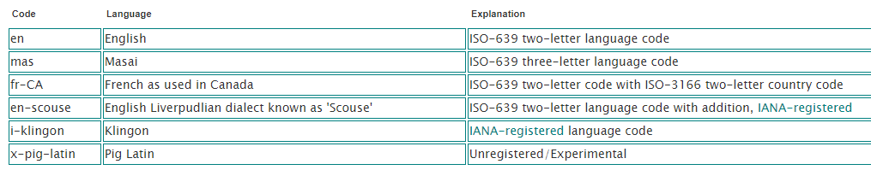

What parts of the S-100 Infrastructure will this proposal affect?

S-100 Feature Concept Dictionary Interface or Database

S-100 Portrayal Register

S-100 Feature Catalogue Builder

S-100 Portrayal Catalogue Builder

S-100 UML Models

S-100 GitHub Schemas

**Please send completed forms and supporting documentation to the secretary S-100WG.**



### 10b-9.6.1 Dataset identification

Table 10b-3 – Dataset identification header elements

|  |  |  |  |  |  |
| --- | --- | --- | --- | --- | --- |
| **Field** | **XML Tag** | **Value** | **Mult.** | **Type** | **Description** |
| … | … | … | … | … | … |
| Dataset language | datasetLanguage | “eng” | 1 | ISO 639-2 3-letter code | The (primary) language used in this dataset |
| ... | … | … | … | … | … |

**S100CSL.xsd**

...

<!-- UnlimitedInteger -->

<xs:simpleType name="UnlimitedInteger">

...

</xs:simpleType>

...

<!-- ISO 639-2 3-letter language code -->

<xs:simpleType name=“languageCode“>

<xs:restriction base=“xs:string“>

<xs:pattern value=“[a-z][a-z][a-z]“/>

</xs:restriction>

</xs:simpleType>

**S100PortrayalCatalog.xsd**

...

<xs:schema

xmlns:xs=<http://www.w3.org/2001/XMLSchema>

xmlns:s100Symbol=<http://www.iho.int/S100SymbolDefinition> version="4.1.0-20191115">

xmlns:s100CSL=“http://www.iho.int/S100ConceptualSchema“

<xs:import namespace="http://www.iho.int/S100SymbolDefinition" schemaLocation="S100SymbolDefinition.xsd"/>

...

<!-- Class for descriptive information about a catalogue item -->

<xs:complexType name="Description">

<xs:sequence>

<xs:element name="name" type="xs:string" minOccurs="0" maxOccurs="1"/>

<xs:element name="description" type="xs:string"/>

<xs:element name="language" type="s100CSL:languageCode"/>

</xs:sequence>

</xs:complexType>

**S100AlertCatalog.xsd**

...

<xs:schema

xmlns:xs="http://www.w3.org/2001/XMLSchema"

xmlns:s100Symbol="http://www.iho.int/S100SymbolDefinition">

xmlns:s100CSL=“http://www.iho.int/S100ConceptualSchema“

<xs:include schemaLocation="S100PortrayalCatalog.xsd"/>

<xs:import namespace="http://www.iho.int/S100SymbolDefinition" schemaLocation="S100SymbolDefinition.xsd"/>

<!-- MESSAGES -->

<xs:complexType name="Text">

<xs:simpleContent>

<xs:extension base="xs:string">

<xs:attribute name="language" type="s100CSL:languageCode" default="eng"/>

</xs:extension>

</xs:simpleContent>

</xs:complexType>

...